1.Created a ec2 machine:
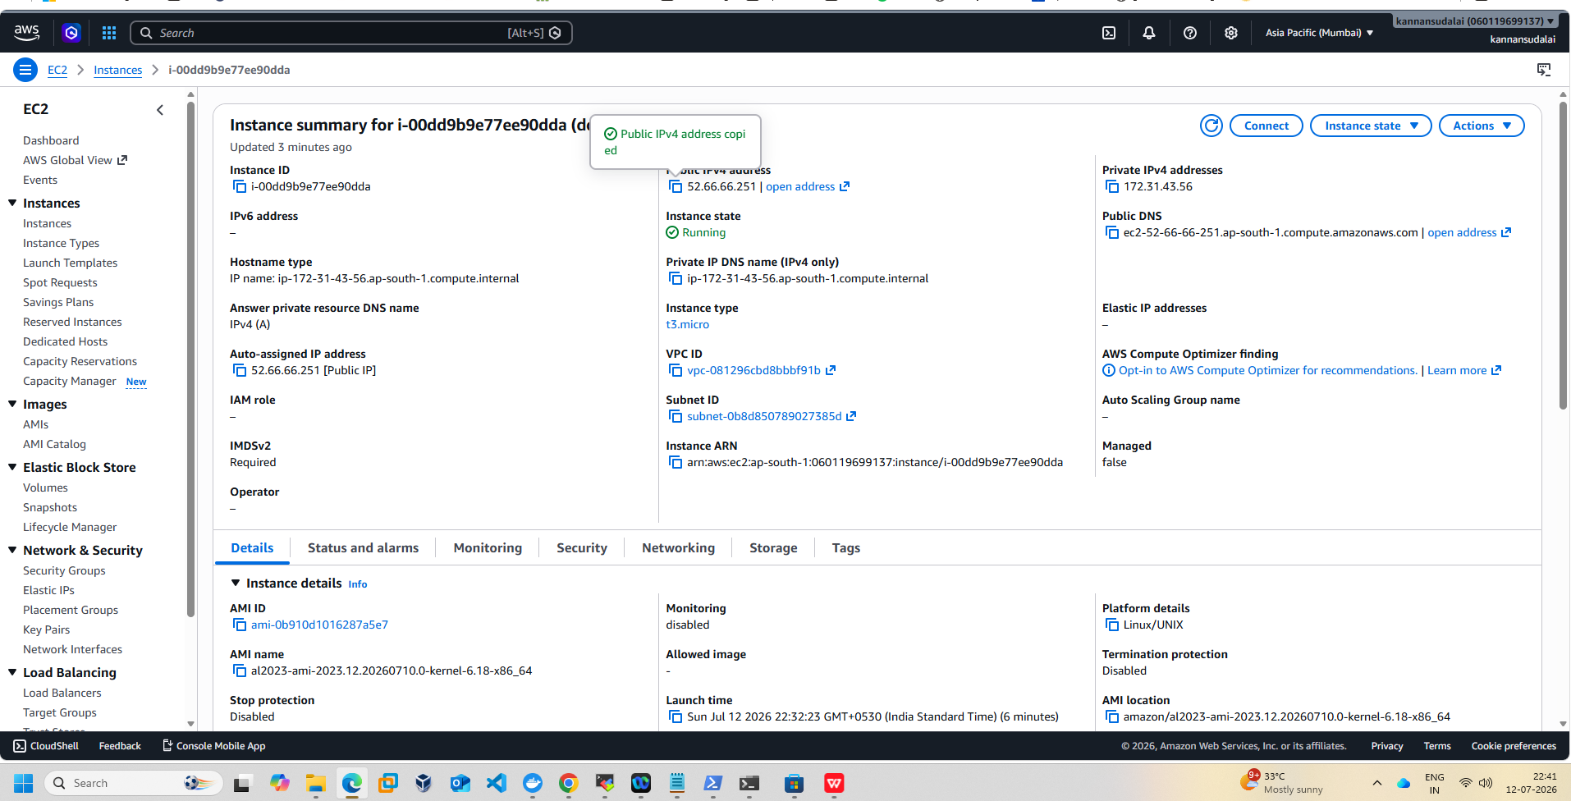
- Took SSH using a private key and user: ec2-user
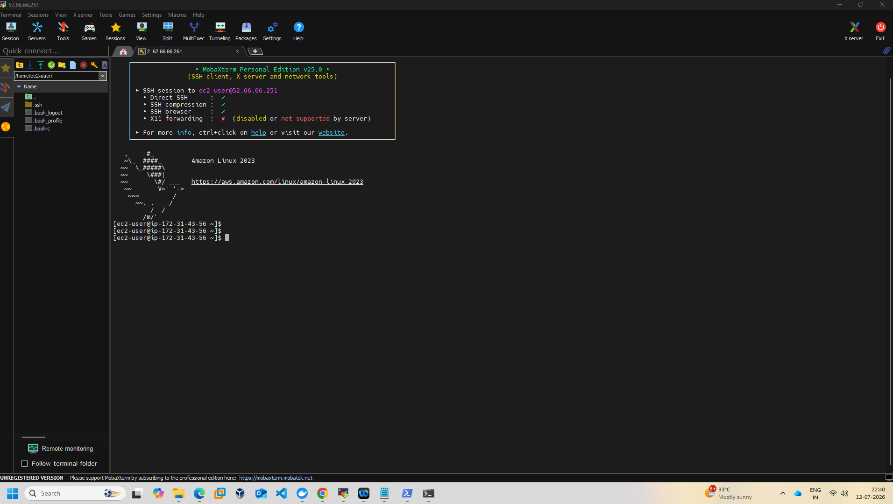
- sudo dnf install docker -y --> installed docker
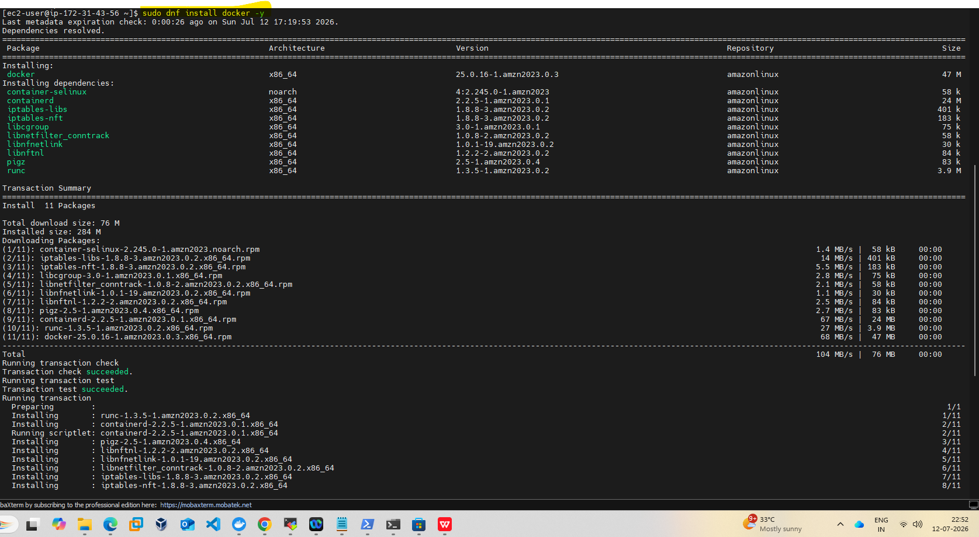

- sudo systemctl enable docker - enabled.

- sudo systemctl start docker & sudo systemctl status docker - Started and running.
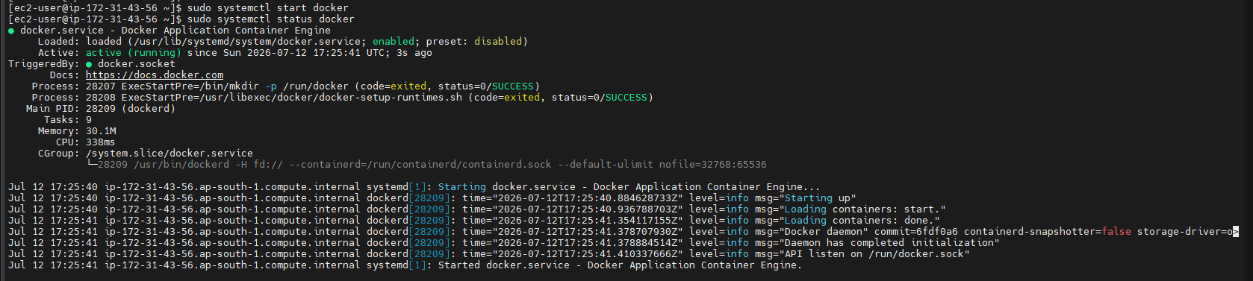

- Ec2-user given docker group permission and tested if docker is able to pull an image --> worked
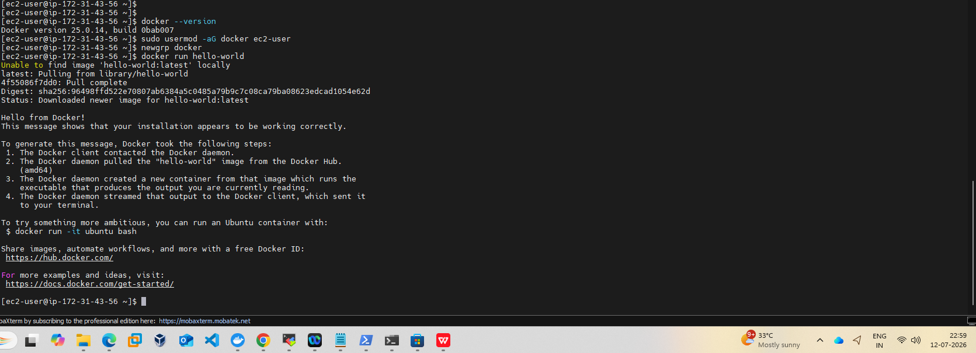

- docker image is pulled and listed under docker images --> running nginx in detached mode.
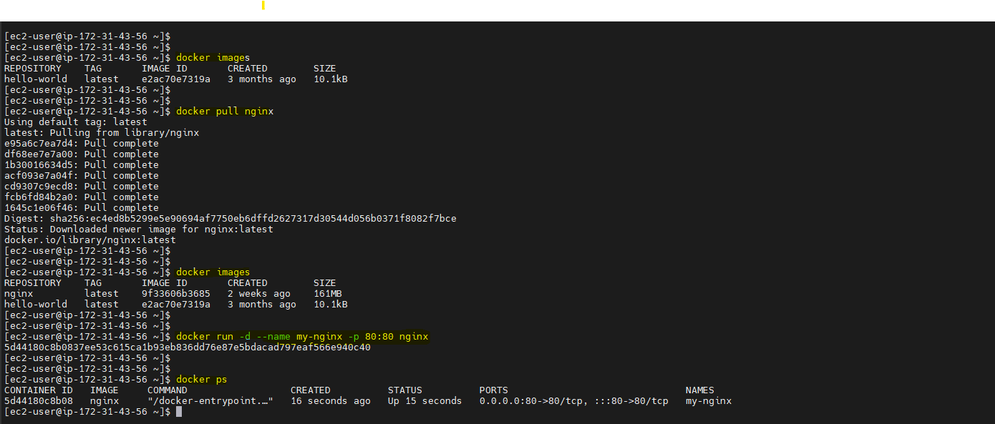

- Docker image is running now and nginx is available to connect .
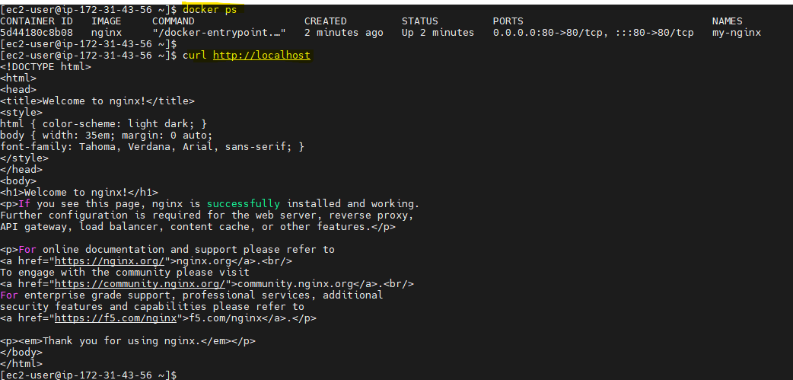

- Nginx running:
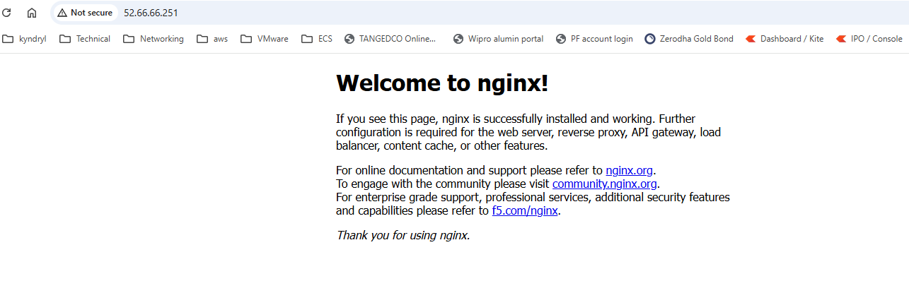

- tried running all below commands: Images and containers related commands
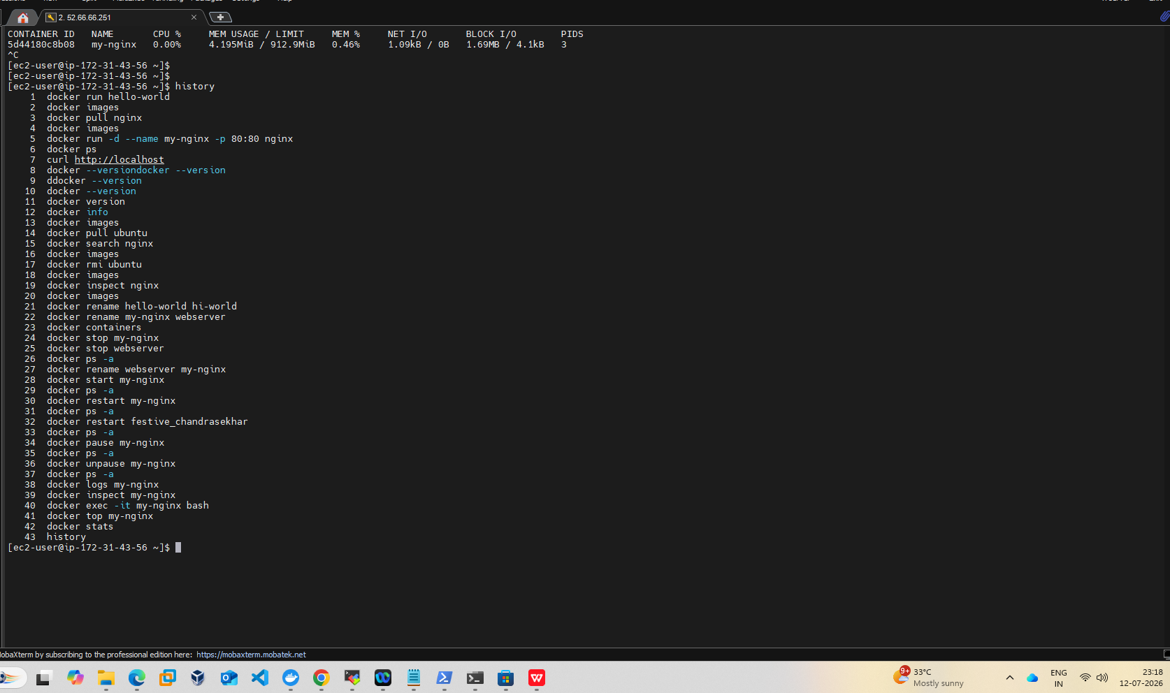

- Docker volume related commands:
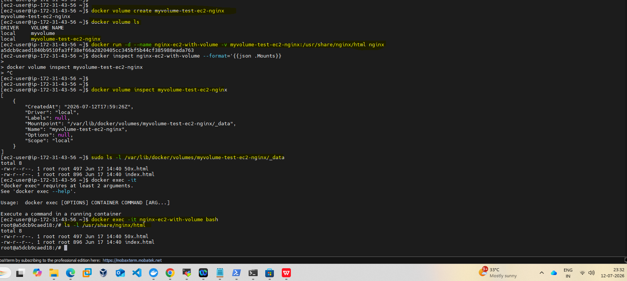
- Docker network related commands:
Create network “mynetwork”
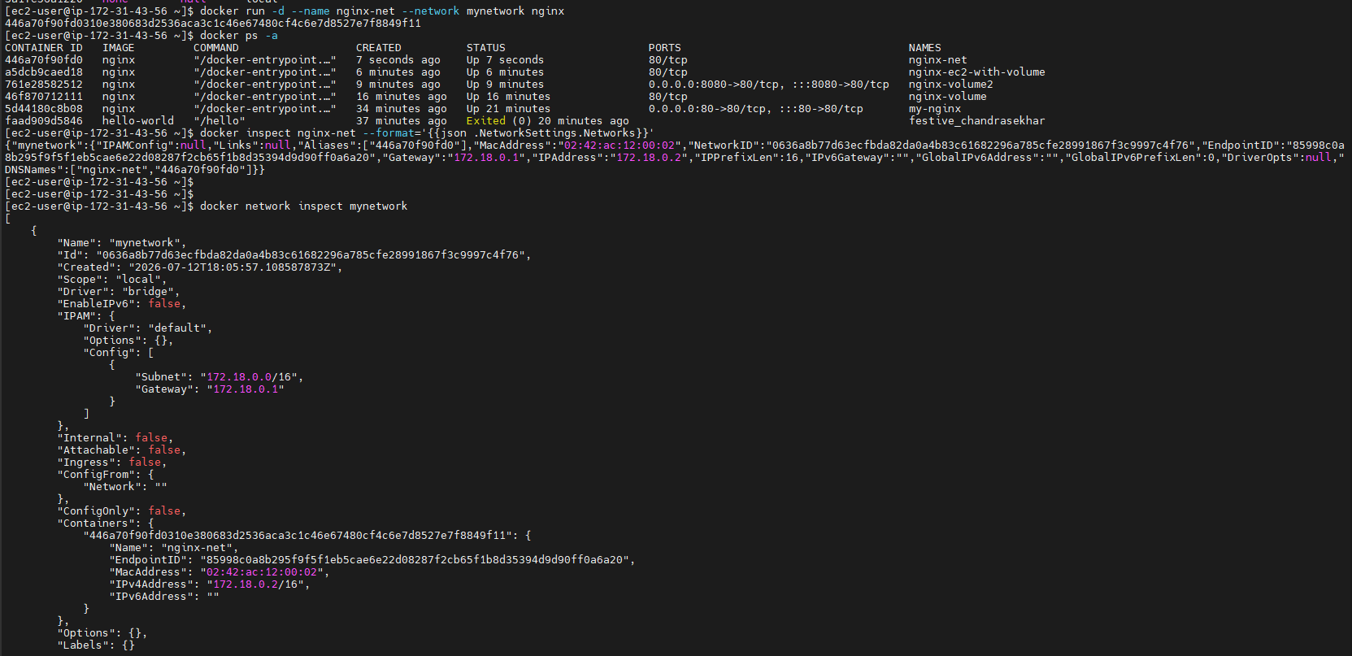
Connecting my-nginx container to mynetwork:
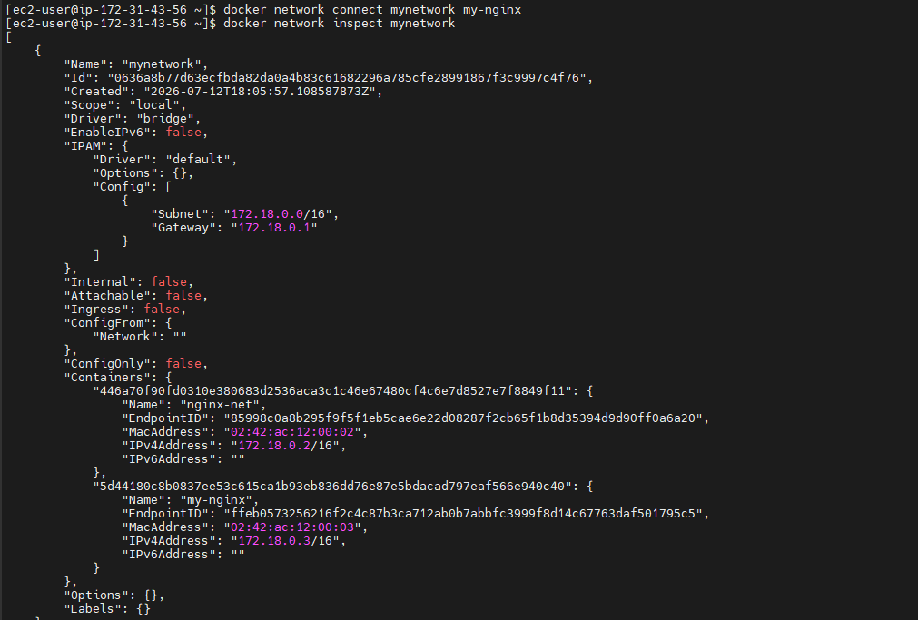
Disconneted the container my-nginx from mynetwork:
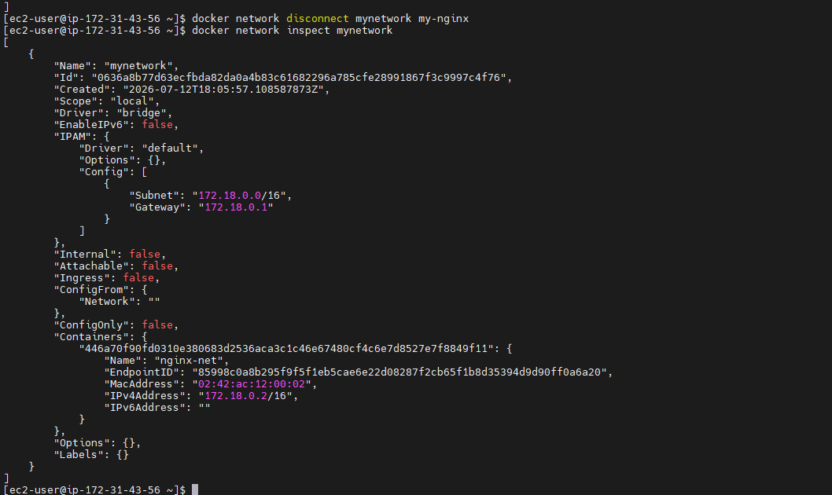

Clean up: Removed all containers and network created.
